Preparing an abstract for the Eleventh European Conference on Wood Modification
Dennis Jones and Holger Militz
Wood Science and Engineering Department, Luleå University of Technology, Forskargatan 1, 931 87 Skellefteå, Sweden. E: dennis.jones@ltu.se
Wood Biology and Wood Products, Georg-August-Universität Göttingen, Büsgenweg 4, 37077 Göttingen, Germany. E: hmilitz@gwdg.de
Keywords: 3 to 7 keywords in alphabetical order
abstract
Please limit the text (including diagrams, tables and references) to maximum two pages, use 12 pt Times Roman font, justified. Cite references in the text using the author’s last name and date of publication as follows (Jones 1999, Jones and Evans 1997, Jones et al. 2003). List citations in alphabetical order at the end of the manuscript (examples are given at the end of this document). Please use full journal titles and not abbreviations. Place figure captions below the figure (use Times Roman 10 pt bold, centred) and refer to as Fig. X in the text, place table captions (use Times Roman 10 pt bold, centred) above the table, refer to as Table X. The deadline for receipt of abstracts is the 15th of September, 2023.

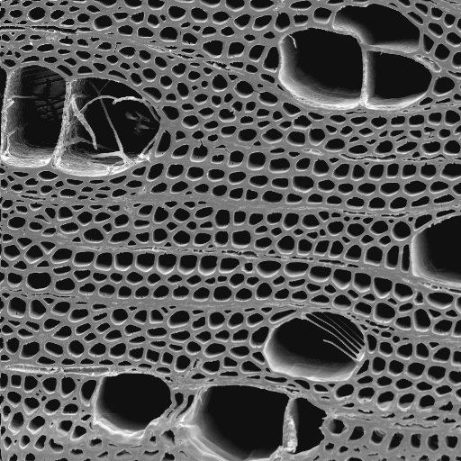
Figure 1: This is the title of Figure 1.

Table 1: This is the title of Table 1.
Sample | Width [mm] | Height [mm] | Weight [g] | Time [s]
1ª | 2 | 1 | 2.5 | 4
2ª | 3 | 2 | 2.4 | 5
3^{b} | 4 | 3 | 2.4 | 6
4^{b} | 5 | 4 | 2.3 | 7
ªHeat treated, ^{b}Acetylated

Use the recommended styles for references.

REFERENCES

Forster, S.C. (1998). Decay resistance of modified softwood. PhD Thesis, University of Wales, Bangor, UK.

Green, F., Clausen, C.A., Micales, J.A. Highley, T.L. and Wolter, K.E. (1989). Carbohydrate-degrading complex of brown-rot fungus Postia placenta: Purification of β-1,4-xylanase. Holzforschung, 43(1), 25-31.

Larsson, P. and Tillmann, A.M. (1989). Acetylation of lignocellulosic materials. The International Research Group on Wood Preservation. Document No. IRG/WP/3516.

Matsuda, H. (1996). Chemical modification of solid wood. In: Chemical Modification of Lignocellulosic Materials. Hon, D.N.S. (Ed.), Marcel Dekker, New York, USA, pp. 159-183.

Repellin, V. and Guyonet, R. (2003). Evaluation of heat treated beech by non-destructive testing. In: Proceedings of the First European Conference on Wood Modification. Ghent, Belgium, pp. 73-82.

